Session | 2024-25 (ODD) |  | Course Name | Web Technology Lab
Semester | 3 |  | Course Code | 23CT1301
Roll No | 43 |  | Name of Student | Chetan M Bobde
Practical Number |  | 8
Course Outcome |  | - Understand various internet technologies.  - Design the web pages using HTML and CSS.  - Implement the XML technology to store the data.  - Develop the interactive web pages using JavaScript.
Aim |  | [A] Write a program in JavaScript to demonstrate the use of While and For Loop.  [B] Write a program in JavaScript to demonstrate the use of Conditional Statements and Functions.
Problem Definition |  | To write a JavaScript program that demonstrates the use of while and for loops for repeating tasks or printing numbers.  To write a JavaScript program that uses conditional statements and functions to make decisions based on given conditions.
Theory  (100 words) |  | JavaScript is a powerful scripting language used to add logic and interactivity to web pages. Loops in JavaScript help to execute a block of code repeatedly. The for loop is used when the number of iterations is known, while the while loop continues execution until a specific condition becomes false. Conditional statements such as if, else if, and else allow the program to make decisions based on conditions and execute different code blocks accordingly. JavaScript functions are reusable blocks of code designed to perform specific tasks. They improve code reusability, readability, and modularity. Using loops, conditions, and functions, JavaScript can efficiently perform logical operations and control program flow.
Procedure and Execution  (100 Words) |  | Step for Implementation:  [A]  1. Start the program.  2. Declare a variable to use in the loop.  3. Use a while loop to print numbers or repeat a task until a condition is false.  4. Use a for loop to perform the same task for a fixed number of times.  5 Display the output on the web page or console.  6 End the program.  [B]  1. Start the program.  2. Define a function to perform a specific task.  3. Use if, else if, and else statements inside the function to check conditions.  4. Call the function with different inputs.  5. Display the result based on the condition.  6. End the program.
Code:
[A]
<!DOCTYPE html>
<html>
<head>
<title>While and For Loop</title>
</head>
<body>
<h2>Demonstration of While and For Loop</h2>
<script>
document.write("<b>Using While Loop:</b><br>");
let i = 1;
while (i <= 5) {
document.write("Number is: " + i + "<br>");
i++;
}

document.write("<br><b>Using For Loop:</b><br>");
for (let j = 1; j <= 5; j++) {
document.write("Square of " + j + " is: " + (j * j) + "<br>");
}
</script>
</body>
</html>
[B]
<!DOCTYPE html>
<html>
<head>
<title>Conditional Statements and Functions</title>
</head>
<body>
<h2>Conditional Statements and Functions in JavaScript</h2>
<script>

function checkNumber(num) {
if (num > 0) {
document.write("The number " + num + " is Positive.<br>");
} else if (num < 0) {
document.write("The number " + num + " is Negative.<br>");
} else {
document.write("The number is Zero.<br>");
}
}

checkNumber(10);
checkNumber(-5);
checkNumber(0);
</script>
</body>
</html>

Output:
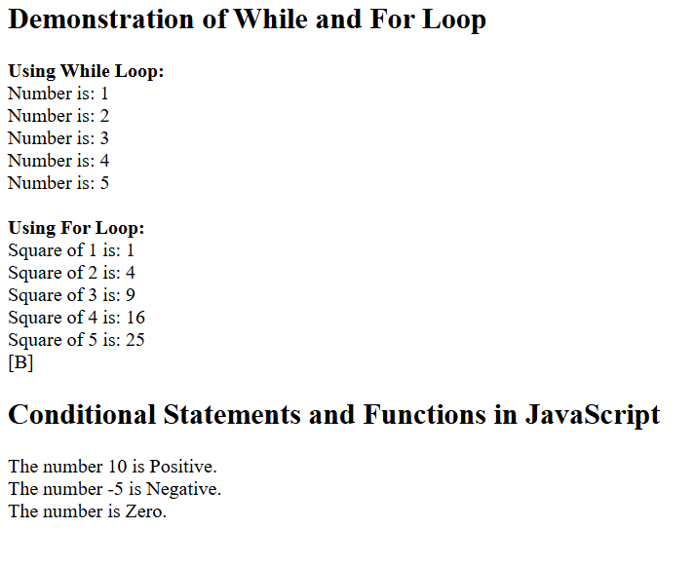
Output Analysis |  | The program prints numbers using while and for loops, showing that both can repeat tasks efficiently until the condition becomes false.  The program checks conditions using if-else inside a function and displays correct results based on input, proving proper decision-making in JavaScript.
Link of student Github profile where lab assignment has been uploaded |  | chetanbob999/Web-technology-
Conclusion |  | In this practical, we successfully learned how JavaScript controls program flow using loops, conditional statements, and functions. The for and while loops help in repeating tasks efficiently, while if-else conditions allow decision-making based on different situations. JavaScript functions improve code structure by making the program reusable and easier to manage. By executing the program in a browser, we observed how loops iterate, how conditions produce different results, and how functions execute specific tasks when called. This practical enhanced our understanding of logic building in programming and demonstrated how JavaScript creates dynamic and interactive web applications.
Plag Report (Similarity index < 12%) |  | 11%
Date |  | 27/10/2025

